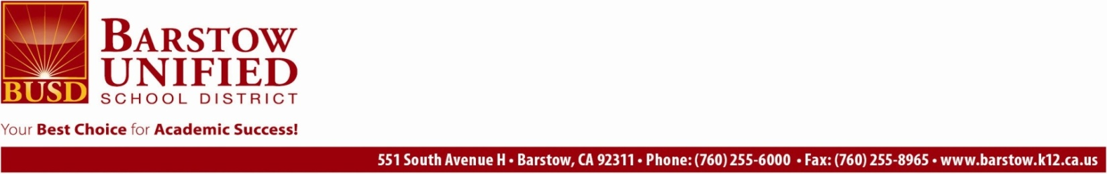

*Pupil Services*

760-255-6028

Fax 760-255-6319

***Heather Reid Ed.D./CI***

**Director II**

760-255-6028

***Carolyn D. Norman***

**CWA Director**

760-255-6039

**MCDD01716_0000[1]MCDD01768_0000[1]MCDD01717_0000[1]**

***Rhonda Powell***

Administrative Assistant

760-255-6028

***Kathy Jarrell***

Child Welfare &

Attendance Technician

760-255-6039

***Debra Lynn***  
Pupil Service Technician

760-255-6027

***Phyllis Henkel***

Office Assistant

760-255-6046

***Ana “Daisy” Alvarez***

Outreach Liaison

760-255-6026

***Central Enrollment Center***

760-255-8800

MEMORANDUM

To: All Staff September 29, 2022

From: Superintendent

Barstow Unified School District has two special education liaisons, one is bi-lingual in Spanish, to assist our parents and guardians in Section 504, Individualized Education Program (IEP), and any other meetings where evaluations, services, instruction, supports, and accommodations for their student(s) with a disability[ies] or suspected of having a disability[ies] are discussed. These staff members are here to help our parents and guardians through the special education process, including by advocating on their behalf in school district meetings.

If you would like to request assistance from one of these staff members at an upcoming meeting, they can be reached at: BUSD Pupil Services Department (760) 255-6028 or by completing the online [Special Education 504 Liaison Request Form](https://forms.gle/SFUdvZ5w465jyLRi9) and one of the following SpEd 504 liaisons will contact you:

Jesenia Hinson (bi-lingual Spanish liaison) ([jesenia\_velasquez@busdk12.com](mailto:jesenia_velasquez@busdk12.com))

Alma Esquivel ([alma\_esquivel@busdk12.com](mailto:alma_esquivel@busdk12.com))

We hope that you will welcome these members of our team to your school-sites, work with them to support our parents, guardians, and students, and make them an integral part of your processes for serving our students with disabilities. The services of our special education liaisons are offered on a voluntary basis to parents, guardians, and students. Please note that parents and guardians may decline the assistance of a liaison at any meeting.

We also want to take this time to remind all staff that any form of retaliation against any individual who advocates, or assists a parent or guardian in advocating, for a student with a disability to obtain services or accommodations, such as our special education liaisons, is prohibited by federal law, state law, and District policy. (Education Code 56046) Prohibited retaliation includes, but is not limited to, intimidation, threats, adverse employment action, unlawful discrimination, or termination of employment.

Any individual who believes that they have been subjected to retaliation based on their advocacy or assistance to a parent in advocating for a student with a disability to obtain services or accommodations may file a complaint with the California Department of Education pursuant to the Uniform Complaint Procedure, a copy of which should also be filed with the District. [<https://barstow.k12.ca.us/District/3927-Williams-Uniform-Complaint-Procedure.html>]. The District will take prompt and appropriate corrective action to protect any individual who believes that they have been subject to retaliation and to respond to allegations of retaliation.

As you may know, the BUSD Director II Pupil Services, Dr. Heather Reid, is our District’s designated Section 504 and Americans with Disabilities Act Coordinator. Please do not hesitate to contact her at [heather\_reid@busdk12.com](mailto:heather_reid@busdk12.com) with any complaints, questions, or concerns.